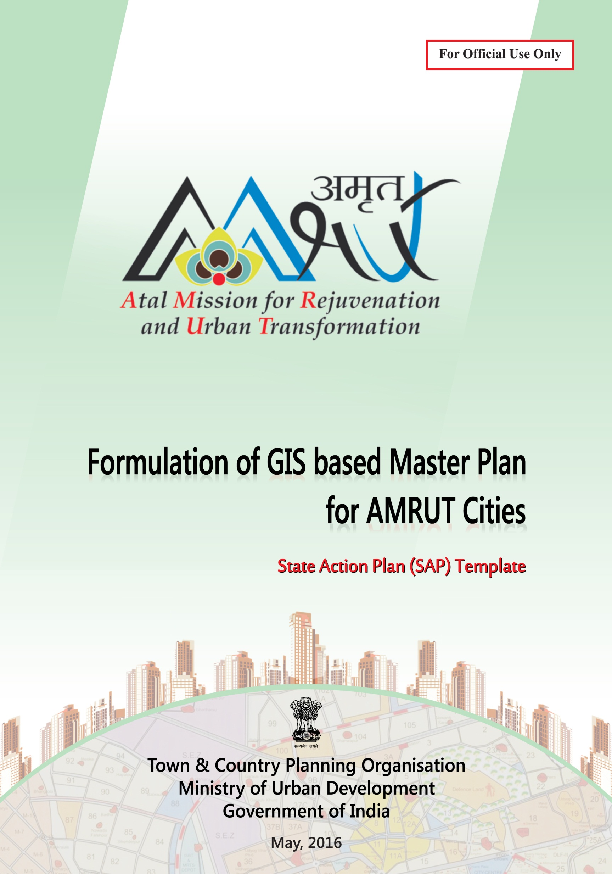

**June, 2016**

**REVISED**



**REFORM AGENDA**

**Formulation of GIS-based Master Plans for AMRUT Cities**

**TEMPLATE FOR STATE ACTION PLAN**

|  |  |  |
| --- | --- | --- |
| Name of State | : | _____________________________________________ |
| Name & Address of State Mission Directorate | : | _____________________________________________  _____________________________________________ |
| Name & Designation of Nodal Officer | : | _____________________________________________  _____________________________________________ |
| Contact | : | Mobile:______________________________________  Tel:_________________________________________  Fax:_________________________________________  Email:_______________________________________ |
| Dated | : | _____________________________________________ |

|  |
| --- |
| * Please read Sub-scheme and RFP documents before filling up this template. * Budgetary requirements over and above Sub-scheme allocation are to be borne by the State Governments. * The State Action Plan prepared by the Nodal Officer in this template is to be approved by the AMRUT State Level Technical Committee (SLTC) and State High Power Screening Committee (SHPSC), which will be approved by Apex Committee at Central Level. * Please attach additional sheets if the number of cities exceeds the number of rows. |

**Filled Template with Signature of Nodal Officer and Seal to be sent to:**

Chief Planner, Town & Country Planning Organisation,

E-Block, VikasBhawan, IP Estate, New Delhi -110002

Fax: 011-23379197

Email: uristcpo@gmail.com

**TEMPLATE FOR STATE ACTION PLAN (PRE-BID STAGE)**

**Table 1 State Name:** ____________________________________

|  |  |  |  |  |  |  |  |  |  |  |  |  |  |
| --- | --- | --- | --- | --- | --- | --- | --- | --- | --- | --- | --- | --- | --- |
|  |  | **Components to be undertaken** | | | | | | **Prioritisation**  **of city**  **(Phase Wise)** | **Geo-database creation\*** | | **Master Plan Formulation\*\*** | | |
| **Sl.**  **No.** | **Name**  **of City** | **A -**  **Geo-database creation** | | | **B -**  **Master Plan Formulation** | | | **Area of mapping**  **(sq.km)** | **Date of conveying area of mapping to TCPO/ NRSC** | **Date of**  **issuing**  **RFP Advt.** | **Date of constituting CERC** | **Date of Awarding Contract** |
| **NRSC**  **(Y/N)** | **In-House (Y/N)** | **Out-Sourcing**  **(Y/N)** | | **In-House (Y/N)** | **Out-Sourcing**  **(Y/N)** |
| **1** | **2** | **3** | **4** | **5** | | **6** | **7** | **8** | **9** | **10** | **11** | **12** | **13** |
| **1** |  |  |  |  | |  |  |  |  |  |  |  |  |
| **2** |  |  |  |  | |  |  |  |  |  |  |  |  |
| **3** |  |  |  |  | |  |  |  |  |  |  |  |  |

**Note: * If the geo-database creation is through NRSC, please fill Column 10 ** If the Master Plan formulation is through out-sourcing, please fill Column 11, 12 &13**

|  |  |  |  |  |
| --- | --- | --- | --- | --- |
| **Explanatory Notes**    Column 3 to 7: The sub-scheme has 3 components: A – geo-database creation and base map preparation, B – master plan formulation and C – capacity building. The above template is for components A & B only. There may be cities for which geodatabase/ updated base map in GIS format already exists and there is no requirement for this component, in that case, “No” has to be filled in Column 3, 4 & 5. There also may be cities for which recent Master Plan exists and therefore there is no requirement for this component, in which case “No” has to be written in Column 6 & 7.  Column 8: Cities are to given priority in four phases as 1, 2, 3 and 4, pl refer table of para 7 of sub-scheme reform agenda. An indicative order for assigning priority is as follows:   |  |  | | --- | --- | | a. Cities for which no master plan exists | b. Cities for which master plan exists but no GIS database exist | | c. Cities for which master plan has expired ie, horizon year is 2015 or before | d. Cities for which master plan horizon year is 2016-2020 |   The state keeping in mind the size and importance of cities and the status of existing plans or lack of it may decide further priorities. Ideally, the phasing should not go beyond three years to cover all AMRUT cities.    Column 9: The area in sq. km. is to be provided in all cases, whether Component A or B or both are being taken up. The area also has to be marked on a map with latitude/ longitude or shapefile. |

|  |  |  |
| --- | --- | --- |
| Signature of Nodal Officer | : |  |
| Official Seal | : |  |
| Date | : |  |



2

**TEMPLATE FOR CAPACITY BUILDING ACTION PLAN (PRE-BID STAGE)**

**Table 2 State Name:** ________________________________

|  |  |  |  |  |
| --- | --- | --- | --- | --- |
| **Identification of Beneficiary Departments** | | **No. of Personnel to be trained** | | |
| **Sl.**  **No.** | **Name of State Govt Department/ Urban Local Body/ Devt. Authority etc.** | **Operators & Technicians level** | **Planning**  **level** | **Administrators**  **level** |
|  |  |  |  |  |
|  |  |  |  |  |
|  |  |  |  |  |

|  |  |  |
| --- | --- | --- |
| **Identification of Training Institute/s** | | |
| **Operators & Technicians level** | **Planning**  **level** | **Administrators**  **level** |
| **4 weeks** | **2 weeks** | **3 days** |
|  |  |  |
|  |  |  |
|  |  |  |

|  |  |  |  |  |  |
| --- | --- | --- | --- | --- | --- |
| **Training Schedule 2016-2019** | | | | | |
|  | **Sl.No.** | **Tentative**  **Schedule**  **(Dates)** | **Level** | **No. of Personnel**  **to be trained** | **Training**  **Institute/s** |
| FY 2016 |  |  |  |  |  |
|  |  |  |  |  |  |
| FY 2017 |  |  |  |  |  |
|  |  |  |  |  |  |
| FY 2018 |  |  |  |  |  |
|  |  |  |  |  |  |
| FY 2019 |  |  |  |  |  |
|  |  |  |  |  |  |

**Explanatory Notes**

The State Mission Directorates will identify the capacity building needs for their respective states including the number of personnel to be trained and year-wise target.

A schedule in the above template will be prepared showing the duration, dates, number and level of personnel to be imparted training. The capacity building will be organized by the State Mission Directorates as per schedule prepared by them.

Standard modules for the same will be provided by TCPO/NRSC. The training programmes will include hands-on training on the use of GIS software including open source GIS/RS technologies, data-base generation and updation for the formulation of Master Plan etc. The duration of the training imparted will depend on the role of the personnel.

|  |  |  |
| --- | --- | --- |
| Signature of Nodal Officer | : |  |
| Official Seal | : |  |
| Date | : |  |

**ESTIMATED BUDGETARY REQUIREMENT FOR STATE ACTION PLAN (PRE-BID STAGE)**

**Table 3 State Name:** ___________________________

**(Rs.)**

|  |  |  |  |  |  |  |  |  |  |  |  |
| --- | --- | --- | --- | --- | --- | --- | --- | --- | --- | --- | --- |
| **Sl.**  **No.** | **City** | **A -**  **Geo-database creation** | | | **B -**  **Master Plan Formulation** | | | **C -**  **Capacity Building** | | | **Total** |
|  |  | **2016-17** | **2017-18** | **2018-19** | **2016-17** | **2017-18** | **2018-19** | **2016-17** | **2017-18** | **2018-19** |  |
| 1 |  |  |  |  |  |  |  |  |  |  |  |
| 2…. |  |  |  |  |  |  |  |  |  |  |  |
|  | **Total** |  |  |  |  |  |  |  |  |  |  |

|  |
| --- |
| **Explanatory Notes: Please refer Annexure-1 of Sub-scheme**  **A - Geo-database creation:** Unit cost of geo-database creation including satellite data acquisition, ortho-rectification and geospatial database creation and base map preparation (excluding spatial attribute collection, ground truthing and vetting) at 1:4000 scale is @Rs. 9529/- per sq. km. for cities having planning areas less than 50 sq.km. and @Rs. 8888/- per sq. km. for cities having planning areas more than 50 sq.km. Budgetary requirement for a city for a particular year can be derived by multiplying the area of mapping with unit cost.  **B - Master Plan Formulation:** Under the sub-scheme, Rs. 1 crore has been allocated for each Metro city and Rs. 75 lakhs for each Class I city for master plan formulation.   * 20% of the project cost will be released on approval of the SAP, as an advance for data acquisition and collection of socio-economic data. * 40% of the project cost of base map & thematic map creation, vetting, and data analysis report. * Next 20% on submission of draft master plan and * Final 20% installment on approval of final master plan * Funds at every stage will be released subject to furnishing of the utilization certificate and physical progress of deliverables duly reported by competent authority.     Under the sub-scheme, State Governments can procure consultancy services for master plan formulation component. The model RFP template may be referred for procuring the consultancy services.  **Budgetary requirements over and above approved Sub-scheme allocation are to be borne by the State Governments.**  **C - Capacity Building:** Under the sub-scheme, Rs.5 lakhs has been allocated for each Metro city and Rs. 2 lakhs for each Class I city for capacity building.  **Funds for geo-database creation will be released to NRSC in case the work is assign to NRSC.**  **If Geo-Database creation, master plan formulation and capacity building done in-house or throughout sourcing the funds will be released to State Governments.** |

|  |  |  |  |  |
| --- | --- | --- | --- | --- |
| **Account Details:** Beneficiary Name________________________________________________________________   |  |  | | --- | --- | | A/C No_______________________________________ | IFS Code_____________________________________ | | Bank_________________________________________ | Branch_______________________________________ | |
|  |

|  |  |  |
| --- | --- | --- |
| Signature of Nodal Officer | : |  |
| Official Seal | : |  |
| Date | : |  |

**TEMPLATE FOR CITY ACTION PLAN & TIMELINES**

**(POST-BID STAGE)**

**Table 4 City Name:** __________(**Separate sheet for each city)**

|  |  |  |  |  |
| --- | --- | --- | --- | --- |
|  | **Sl.**  **No.** | **Action Plan** | **Timelines** | |
|  |  |  | **Month** | **Year** |
| **A -BASE MAP PREPARATION** |  | Ground truthing and incorporation  Value addition from line departments/ ULBs |  |  |
|  | Vetting of maps by State Governments/ ULBs |  |  |
| **B - MASTER PLAN FORMULATION** |  | Data collection & surveys by Consultant |  |  |
|  | Data analysis report including generation of thematic maps, charts, diagrams, etc. |  |  |
|  | Identification of issues & potentials |  |  |
|  | Projected Requirements |  |  |
|  | Draft proposals |  |  |
|  | Draft master plan |  |  |

**Note:**

**Please fill in Part A in consultation with NRSC or Consultant for Base Map Preparation as the case may be.**

**Please fill in Part B corresponding to information given in State Action Plan after opening the bids and signing of contract with Consultant.**

|  |  |  |
| --- | --- | --- |
| Signature of Nodal Officer | : |  |
| Official Seal | : |  |
| Date | : |  |

**ACTUAL BUDGETARY REQUIREMENT FOR STATE ACTION PLAN**

**(POST-BID STAGE)**

**Table-5 State Name:** ____________________________

**(Rs.)**

|  |  |  |  |  |  |  |  |  |
| --- | --- | --- | --- | --- | --- | --- | --- | --- |
| **Sl.**  **No.** | **City** | **A -**  **Geo-database Creation** | | | **B -**  **Master Plan Formulation** | | | **Total** |
| **2016-17** | **2017-18** | **2018-19** | **2016-17** | **2017-18** | **2018-19** |
| **1** |  |  |  |  |  |  |  |  |
| **2** |  |  |  |  |  |  |  |  |
| **3** |  |  |  |  |  |  |  |  |
| **4…** |  |  |  |  |  |  |  |  |
|  | **Total** |  |  |  |  |  |  |  |

|  |
| --- |
| **Explanatory Notes**    **A- Geo-database Creation:** State Governments create the geo-database through NRSC/in-house or through out-sourcing (consultancy services). The Design & Standards Document may be referred while creating geo-database. The budgetary requirement will depend upon actual expenditure in case of in-house and the consultant’s fee as per contract in case of out-sourcing.  **B-Master Plan Formulation:** State Governments can formulate Master Plan in-house or through out-sourcing (consultancy services). The model RFP template may be referred for procuring the consultancy services. The budgetary requirement will depend upon actual expenditure in case of in-house and the consultant’s fee as per contract in case of out-sourcing.  **Budgetary requirements over and above approved Sub-scheme allocation are to be borne by the State Governments.** |

|  |  |  |
| --- | --- | --- |
| Signature of Nodal Officer | : |  |
| Official Seal | : |  |
| Date | : |  |